Whooping Crane
Operational Contingency Plan

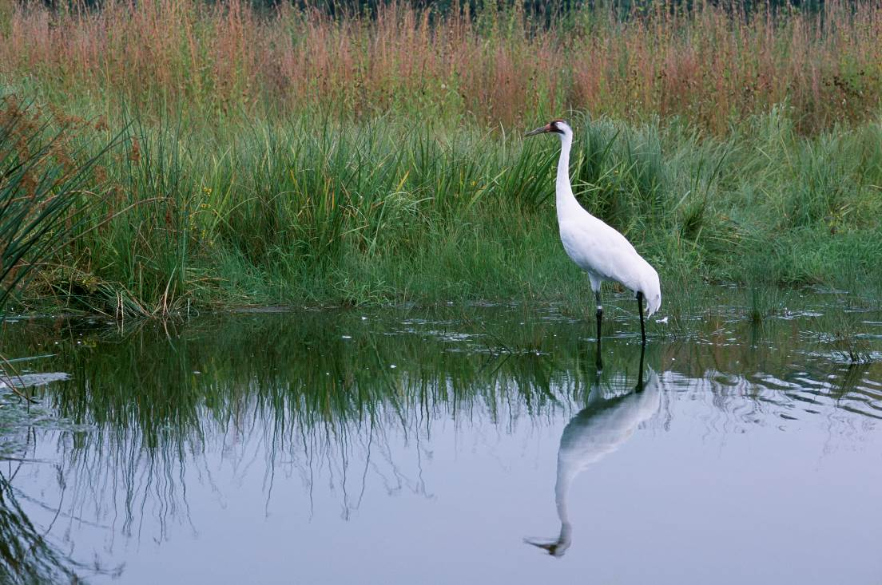
USFWS Image

Prepared by:

Prepared for:
Nebraska Game and Parks Commission and the U.S. Fish and Wildlife Service

Date:
Contents

Overview 2
Training for Employees 3
Operational Responses to Observation of Whooping Cranes 4
Operational Contingency Plan Review 4
Appendix B: Operational Response to Whooping Crane(s) Observed on the Ground 7
Appendix C: Wind Energy Facility Points of Contact 9
Appendix D: Agency Points of Contact 10
Appendix E: Whooping Crane Sighting Notification Form 11
Appendix F: Plan Revision History 14

Overview
An operational contingency plan outlining what steps will be taken in the unlikely event a Whooping Crane is observed near a wind energy project can help reduce the potential for Whooping Crane-wind turbine collisions.
The Whooping Crane is state and federally listed as an endangered and is found in Nebraska during spring and fall migration. While never abundant, Whooping Crane numbers were reduced due to unregulated hunting and habitat loss. The Aransas-Wood Buffalo population of Whooping Cranes has rebounded from less than 20 individuals in the 1940s to around 300 in the 2010s; it is the only self-sustaining wild population of Whooping Cranes remaining in the United States. This population of Whooping Cranes migrates though Nebraska in both spring and fall between wintering areas at and around Aransas National Wildlife Refuge along the Texas Gulf Coast and breeding sites at and around Wood Buffalo Park in northern Alberta. Migration through Nebraska is typically from March through early May and late September through December. Observations of Whooping Cranes in the state occasionally occur outside of these periods.
Although Whooping Cranes migrate at elevations higher than 1,000 feet, they rely on frequent stopover sites to rest and feed. It is in approach or departure to these stopovers and during flights to feeding areas while at stopover locations that Whooping Cranes are more susceptible to collisions with structures, such as wind turbines and powerlines. Stopover locations are typically used for several days and evidence suggests the same locations are preferred by sequential groups of Whooping Cranes throughout a migration. Inclement weather during stopovers can reduce the Whooping Cranes abilities to see and avoid structures. Additionally, although Whooping Cranes generally migrate during daylight hours, they have also been documented migrating after dark which may increase the likelihood of collisions with structures near stopover locations. Because Whooping Cranes can descend in altitude very quickly, may spiral to gain altitude, use low-level flights between roost and foraging locations, and can travel five miles in six or seven minutes with a tail wind, modifying wind energy facility operations when Whooping Cranes are within five miles of a wind energy facility is judicious.
Due to the low number of Whooping Cranes in this endangered population, avoiding and minimizing potential impacts of wind energy development and operation on migrating Whooping Cranes is crucially important for the safety of the population. A 200+ mile wide Whooping Crane migration corridor (Figure 1) was described in 2009, based on 95% of past Whooping Crane sightings confirmed during migration through the Spring of 2008. Whooping Cranes have been, and continue to be, observed outside of this corridor. While the probability of Whooping Crane occurrence decreases toward the outside boundaries of the described corridor, it is possible that a Whooping Crane(s) will migrate over or stop near a project area outside the migration corridor. Therefore, it is pragmatic for wind energy developers and operators to develop an operational contingency plan for Whooping Cranes for wind energy development projects in Nebraska that can help reduce the potential for Whooping Crane collisions with wind turbines.
This operational contingency plan is being submitting by as part of the mitigation agreement with the Nebraska Game and Parks Commission (NGPC) and the United States Fish and Wildlife Service (USFWS) regarding the project in county. This plan is intended to serve as a means to reduce the risk of the project to migrating Whooping cranes.
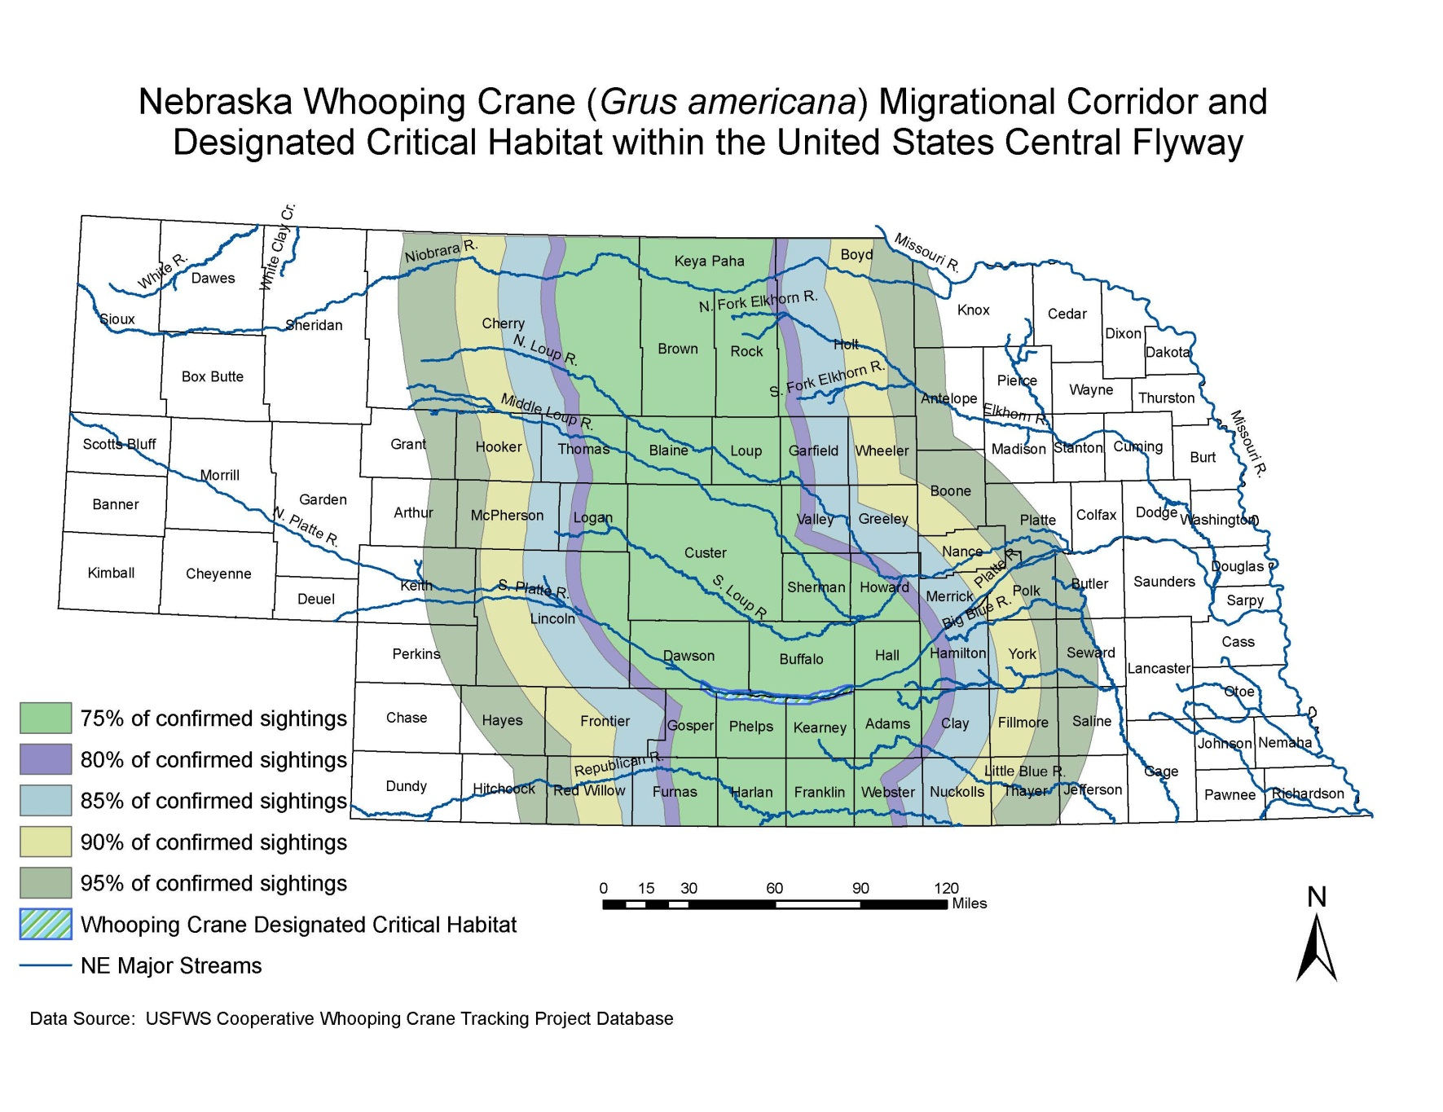
Figure 1. Whooping Crane Migration Corridor and Designated Critical Habitat in Nebraska

Training for Employees
To ensure that company employees as well as all Original Equipment Manufacturer (OEM) employees can identify Whooping Cranes and be prepared to implement contingencies, all personnel will receive training on this contingency plan prior to the start of each migratory season. In addition to the contingency plan training, additional training will be conducted on an annual basis for the site’s Wildlife Incident Reporting procedure.
The Whooping Crane Operational Contingency Plan training will be documented and kept on file at the wind site office building. The following are the minimum topics that will be covered during the training:
- History and behavior of the Whooping Crane
- How to distinguish the Whooping Crane from similar species (i.e. American White Pelican, Trumpeter Swan, Snow Geese)
- Reporting procedures if a Whooping Crane(s) is sighted
- The definition of wildlife harassment and how to avoid harassing Whooping Cranes and other wildlife
- How to properly use binoculars
The recommended photographs and pertinent information will be posted year round in a common area of the main office building to aid in the education and identification of the species. A pair of binoculars will be available in each company vehicle used on-site at the wind energy facility and in the main office for use in identifying Whooping Cranes and other wildlife.

Operational Responses to Observation of Whooping Cranes
All (insert company name) and OEM employees who observe Whooping Cranes in flight or on the ground within five miles of the wind energy facility shall immediately notify via cell phone or radio the Site Manager or designee. Information to be provided includes, but is not limited to, number of Whooping Cranes, location of Whooping Crane(s) (include turbine location and proximity), height of travel if in flight or if the individual(s) are on the ground.
The Site Manager or designee and observer shall then take steps outlined in the flow charts in Appendix A and Appendix B in this plan.
If at any point a sick, injured or dead Whooping Crane is observed at or near the facility, no attempts to capture the bird or touch the carcass will be made. The USFWS will be immediately contacted (Appendix D) and the conditions under which incident occurred will be recorded.

Operational Contingency Plan Review
Appendices C and D of this plan shall be reviewed and updated at least annually; the remainder of the plan will be reviewed and updated as needed, but at least every five years. The site manager will ensure that agency and facility contact information is current. Any updates to the plan shall be made in cooperation with NGPC and USFWS.
Appendix A: Operational Response to Whooping Crane(s) Observed in Flight

Individual who observes Whooping Crane in flight or designated observer
Immediately contacts the site manager or designee (Appendix C) by phone or radio if a Whooping Crane (s) is observed within 5 miles of the wind energy facility. Provides: 1) location, 2) number of cranes, and 3) whether the Whooping Crane(s) is at, above, or below rotor blade sweep.
If Whooping Crane(s) is ABOVE rotor blade sweep, continue to observe flight pattern.
The Whooping Crane(s) lands within 5 miles of the wind energy facility - follow procedures in Appendix B.
If the Whooping Crane (s) is AT or BELOW rotor blade sweep, controlled shut down will begin.
The Whooping Crane(s) descends to AT or BELOW the rotor blade sweep.
Keeps site manager or designee updated on Whooping Crane(s) movements.

Site manager or designee
If Whooping Crane(s) is AT or BELOW rotor blade sweep
If Whooping Crane(s) is ABOVE rotor blade sweep
Notifies USFWS and NGPC (Appendix D) and coordinates with to determine additional courses of action and monitoring of the Whooping Crane(s).
Complete the Whooping Crane Sighting Notification Form (Appendix E), submit it to NGPC and USFWS, and file on site.
Once notified Whooping Crane(s) is more than 5 miles from the nearest wind turbine for at least fifteen minutes, curtailed turbines can be become operational.
Notifies observer if they can leave their post.
Advises observer to continue to monitor Whooping Crane(s) within 5 miles of the wind energy facility.
Within 5 miles of wind energy facility and visibility is greater than 1/2 mile
Begins controlled shut down of wind turbines within 5 miles of the Whooping Crane(s) location.
Within 5 miles of wind energy facility and visibility is less than 1/2 mile
Begins controlled shut down of ALL wind turbines.

Appendix B: Operational Response to Whooping Crane(s) Observed on the Ground

Individual who observes Whooping Crane on the ground or designated observer
Immediately contacts the site manager or designee (Appendix C) by phone or radio if a Whooping Crane (s) is observed within 5 miles of the wind energy facility. Provides: 1) location and 2) number of cranes.
Remains at location, staying on access roads at a distance where crane(s) behavior is not altered by human presence.
Continues to monitor until notified by site manager or designee that monitoring is no longer needed.
Records crane(s) movements within or away from site and direction of movement.
Notifies site manager or designee when Whooping Crane(s) is more than 2 miles from the nearest wind turbine.
If a Whooping Crane(s) is within 2 miles of the wind energy facility

Site manager or designee
Whooping Crane(s) within 2 miles of wind energy facility and visibility is greater than 1/2 mile
Whooping Crane(s) within 5 miles of wind energy facility, but more than two miles from a turbine
Whooping Crane(s) within 2 miles of wind energy facility and visibility is less than 1/2 mile
Begins controlled shut down of wind turbines within 2 miles of the Whooping Crane(s) location.
Begins controlled shut down of ALL wind turbines.
Notifies USFWS and NGPC (Appendix D) and coordinate with to determine additional courses of action and monitoring of the Whooping Crane(s).
Complete the Whooping Crane Sighting Notification Form (Appendix E), submit it to NGPC and USFWS, and file on site.
Once notified Whooping Crane(s) is more than 5 miles from the nearest wind turbine for at least 15 minutes, curtailed wind turbines can be become operational.
Notifies observer if they can leave their post.

Appendix C: Wind Energy Facility Points of Contact

Site Manager

Name:

Cell phone number:

Email:

Other contact information:

Designee

Name:

Cell phone number:

Email:

Other contact information:

Appendix D: Agency Points of Contact

Nebraska Game and Parks Commission  Michelle Koch |  | Joel Jorgensen
Fish and Wildlife Specialist  Nebraska Game and Parks Commission |  | Nongame Bird Program Manager  Nebraska Game and Parks Commission
2200 North 33rd Street |  | 2200 North 33rd Street
Lincoln, NE 68503 |  | Lincoln, NE 68503
Office: (402) 471-5438 |  | Office: (402) 471-5440
Cell: (308) 380-7647 |  | Cell: (402) 533-0924
michelle.koch@nebraska.gov |  | joel.jorgensen@nebraska.gov

U.S. Fish and Wildlife Service, Nebraska Field Office
Eliza Hines
Assistant Field Supervisor
U.S. Fish and Wildlife Service, Nebraska Field Office
9325 South Alda Road
Wood River, Nebraska 68883
Office: (308) 382-6468, Extension 204
eliza_hines@fws.gov

Appendix E: Whooping Crane Sighting Notification Form

Date of Whooping Crane(s) sighting: Time of Whooping Crane(s) sighting:
Observer name(s) and company:

Location of sighting:
Turbine #: Distance (m) from turbine: Direction from turbine:
Turbine #: Distance (m) from turbine: Direction from turbine:
Turbine #: Distance (m) from turbine: Direction from turbine:
Turbine #: Distance (m) from turbine: Direction from turbine:
Turbine #: Distance (m) from turbine: Direction from turbine:

Number of Whooping Crane(s) observed:
Order of Whooping Crane(s) behavior observed:
Flying above rotor blade sweep Flying at or below rotor blade sweep On the ground Other:

Name of USFWS employee contacted:
Date: Time: Was a message left? Yes: No:

Name of NGPC employee contacted (or message left):
Date: Time: Was a message left? Yes: No:

Were any turbines curtailed? Yes No
Turbine identification number(s) curtailed:
Curtailment start date: Time:
Curtailment end date: Time:
Date Whooping Crane Left Project Area: Time:

Form Completed By: Date:

Maintain completed form for the life of the project on file at project site AND forward a copy to NGPC and USFWS (Appendix D).

Additional Comments:

Appendix F: Plan Revision History

Date of revision:
Description of changes:
Revisions made by:

Date of revision:
Description of changes:
Revisions made by:

Date of revision:
Description of changes:
Revisions made by:

Date of revision:
Description of changes:
Revisions made by:

Date of revision:
Description of changes:
Revisions made by:

Date of revision:
Description of changes:
Revisions made by:

Date of revision:
Description of changes:
Revisions made by:

Date of revision:
Description of changes:
Revisions made by:

Date of revision:
Description of changes:
Revisions made by:

Under the authorities of the Endangered Species Act of 1973 and the Nebraska Nongame and Endangered Species Conservation Act (§37-801-11)

